***Serverless Functions with AWS Lambda***

**Description:** Developed serverless functions to handle event-driven processing tasks, enabling seamless data flow and integration with other AWS services.



**Technologies Used:** AWS Lambda, Python/Node.js, API Gateway.



**Step 1:-**  Select Lambda or search lambda in search tab.



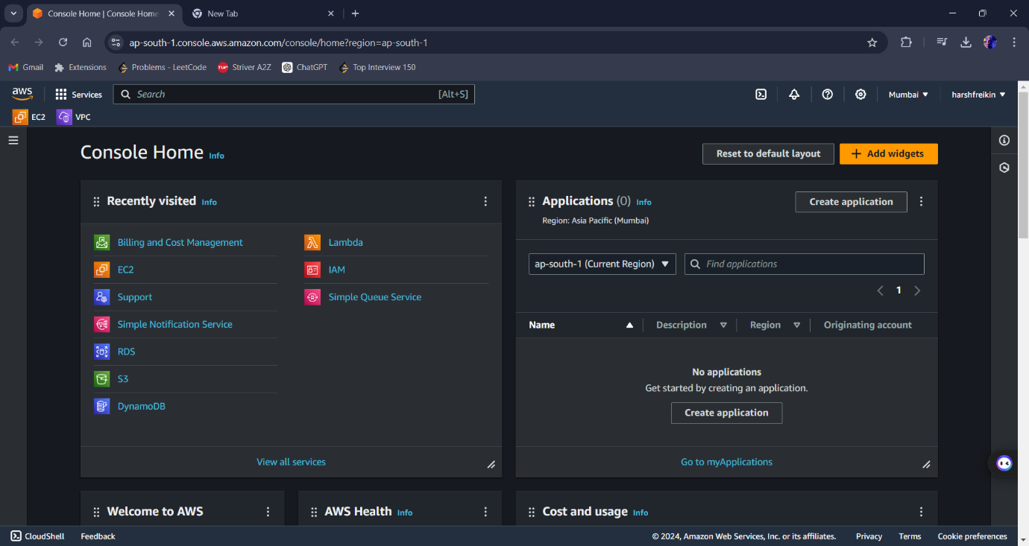

**Step 2:-** After Opening the Lambda window clink on create Function to create a new function.

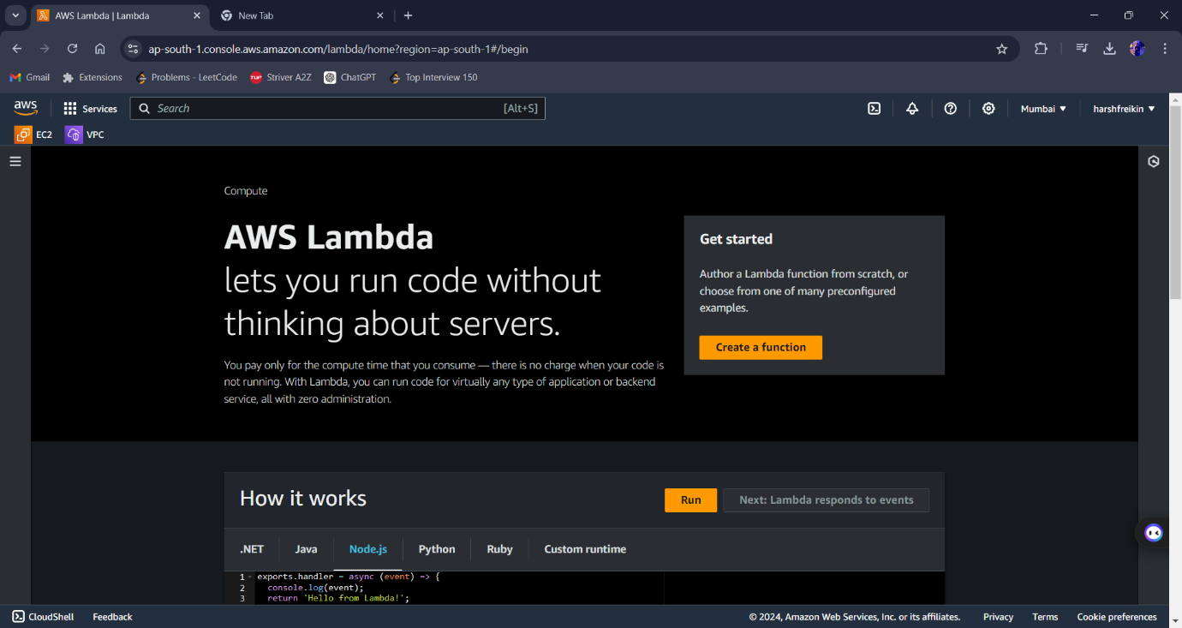

**Step 3:-** Select Author from Scratch, Enter Function name, Select Runtime language and set all as default.

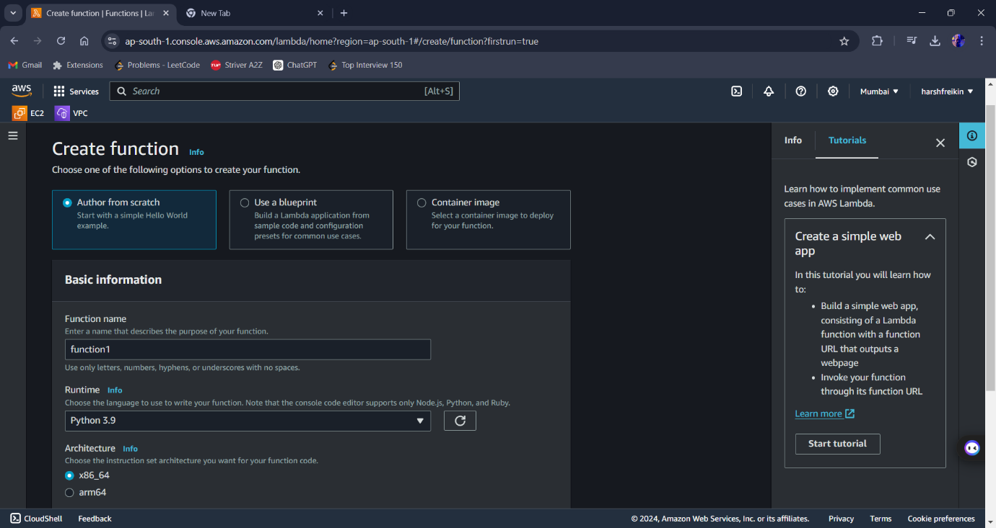

**Step 4:-** After adding all the information, click on create Function.

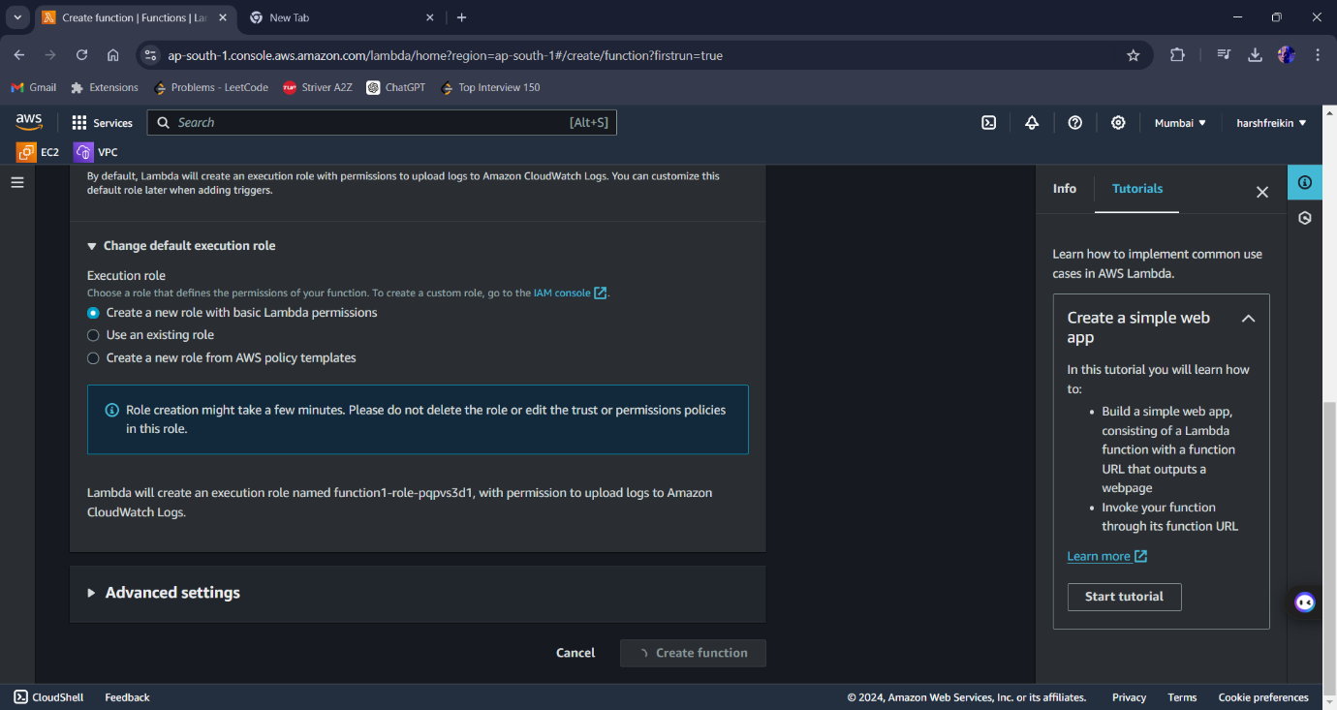

**Step 5:-** Now Function page open , scroll down……

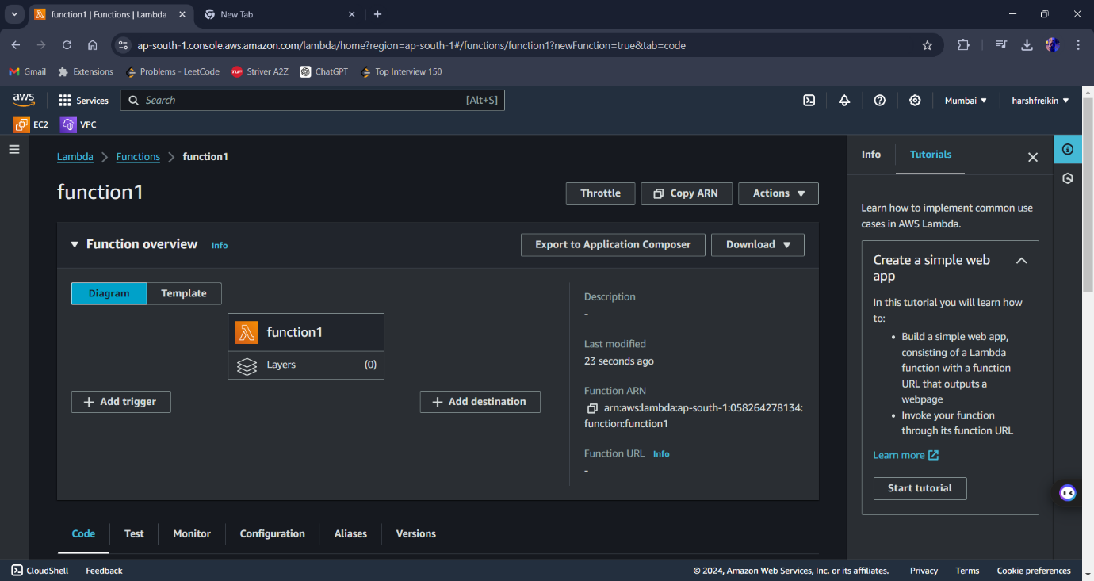

**Step 6:-** Stop and Edit the code according to you.

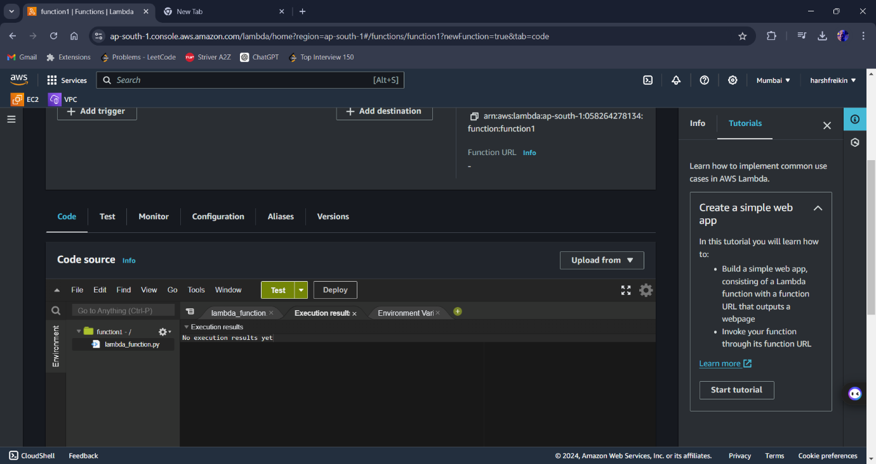

**Step 7:-** After editing come back and click on ADD TRIGGER option.



**Step 8:-** search API GATEWAY on search menu in trigger configuration and select it.

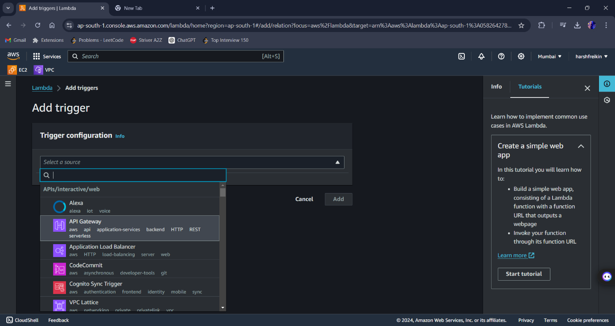

**Step 9:-** After selecting the gateway, now select create a new topic, then Rest API , security set as open and lastly click on ADD.

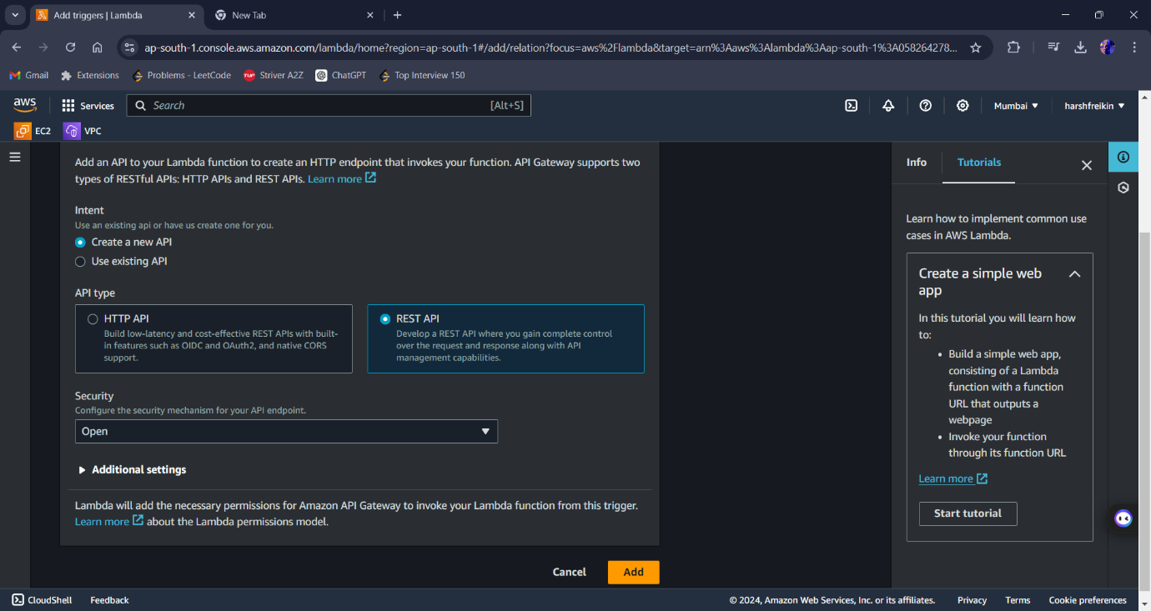

**Step 10:-** Click on Gateway Trigger in function, now new window opens same as below. Click on API endpoint Link.

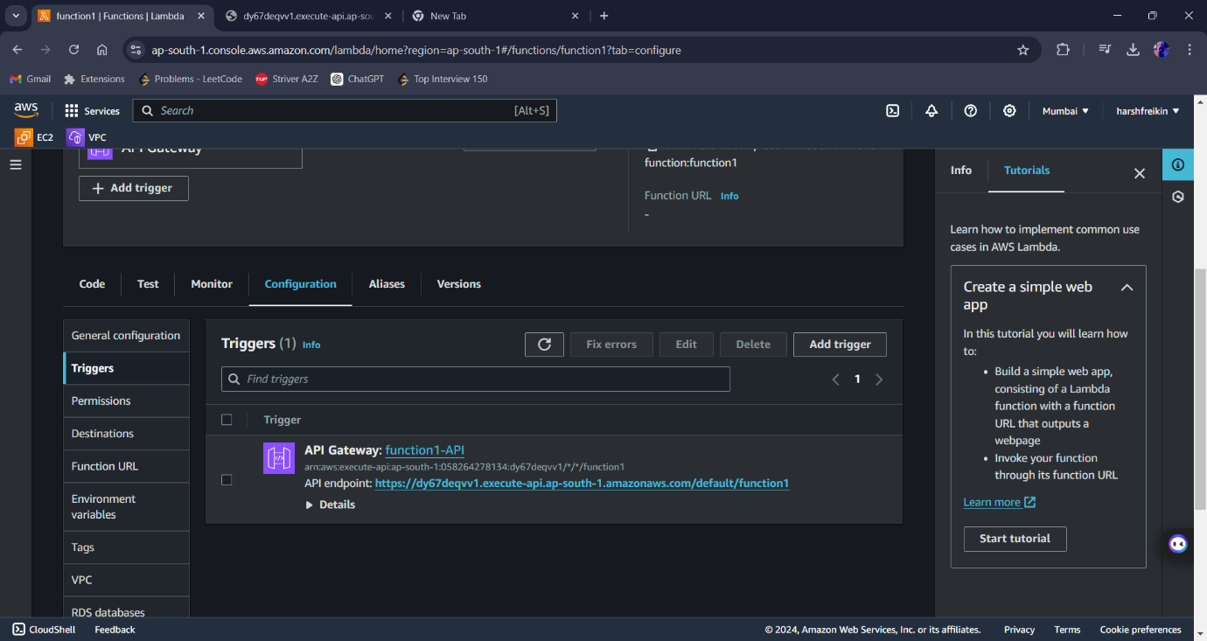

**Step 11:-** After Clicking your serverless function/window opens and successful.

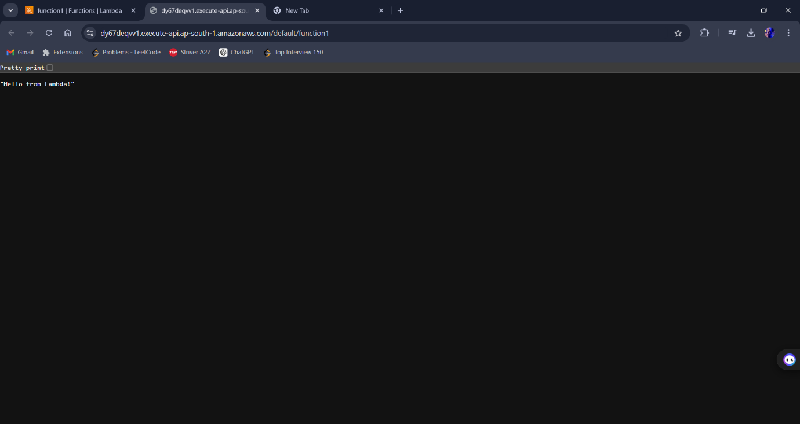

These step is used to create serverless service or without creating instance and doing long process of connecting and all.